Category
Title:
Subtitle

The names of all author(s) (Final manuscript)

Title（Japanese）
―Subtitle（Japanese）―

SUMMARY: This journal uses double-blind review, which means that both the reviewer and author identities are concealed from the reviewers, and vice versa, throughout the review process. A blinded manuscript should be prepared. Manuscripts should be in one of the following five categories: (a) research articles, (b) research notes, (c) reviews or review articles, (d) remarks and replies, or (e) squibs. Manuscripts of research articles, research notes, and review articles should be accompanied with an English summary of approximately 100 words.

Key words: 5 to 8 keywords

The affiliation(s) of author(s)（English and Japanese）(Final manuscript)

1.
This template has been created to facilitate the process of submissions to the Journal of the Phonetic Society of Japan. It is not intended to directly correspond to the printed article. One page of the template corresponds approximately to half a page of the printed article.
Manuscripts of research articles and review articles should not exceed 14 printed pages of the journal, including summary, notes, tables, figures and references. Squibs should not exceed two printed pages. As for other types of manuscripts, the shorter, the better.

2.
2.1
Please ensure that the figures and the tables are placed close to the relevant text in the manuscript. The figures and the tables should be prepared at a sufficient resolution for printing.
2.1.1

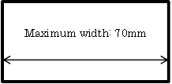
Figure 1 Title is shown below the figure body (1/2page)

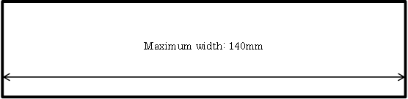
Figure 2 Title is shown below the figure body (1page)

Table 1 Title is shown above the table body
 | English manuscript
A | 1
B | 2

3.
A full bibliography should be given at the end of the manuscript with the heading References. Examples of reference style are given below. Citation in the text should be given as: Kiritani, Itoh and Fujimura (1975)，(S. Haraguchi 1991, p. 107, M. Sugito and H. Hirose 1978, pp. 35–36). The first names of the authors may be given in full, or can be indicated by initials.

Acknowledgments
The author’s name, affiliation, JSPS KAKENHI Grant Number, et al. in the manuscript should be deleted.
Notes
Endnotes should be used instead of footnotes.

References
Haraguchi, Shosuke (1988) “Pitch accent and intonation in Japanese.” In Harry van der Hulst and Norval Smith (eds.) Autosegmental studies on pitch accent, 123–150. Dordrecht: Foris.
Haraguchi, Shosuke (1991) A theory of stress and accent. Dordrecht: Foris.
Kiritani, S., K. Itoh and O. Fujimura (1975) “Tongue-pellet tracking by a computer-controlled X-ray microbeam system.” Journal of the Acoustical Society of America 57(6), 1516–1520.
National Language Research Institute. “A cineradiography of Japanese pronunciation.” http://www6.kokken.go.jp/x-sen/ (accessed May 20, 2010)

